**Network Programmability as a Cloud Service**

**Project Proposal**

1. **Vision and Goals of the Project**

To implement a mechanism with which IaaS providers can have same kinds of control on the hardware irrespective of ownership of those hardware components.

The primary goal of this project is to provide network resources and their control as a service which can be used by multiple cloud providers and/or tenants. The service creates fully virtualized network resources that could be managed and controlled independently.

The tenants will have a unified view of the network irrespective of the hardware administrative domain in which the devices are placed.  
  
Users:   
The service will be used by tenants and IaaS providers

1. **Scope and features of the Project**

* Offer same control of networking resources over different hardware to IaaS providers (Tenants)
  + Introducing an abstraction layer to support services across multiple vendor switches (hardware) and controllers.
  + Facilitating communication across clouds using different controllers.
  + Providing Bandwidth and QoS agreement across multiple tenants in MOC.
* Extensibility: Providing networking services and SLAs to higher level providers and tenants while having different hardware providers

1. **Solution Concept**

Our task includes creating a multi-tenant SDN network using Mininet

**Mininet:** Mininet is network simulator to create host/servers, switches and routers. It use Python to create topologies. Hosts in Mininet behave just like real machine, we can even SSH into it. Host can also transmit packets with a mentioned speed and delay. Switch also process the packet with queuing.

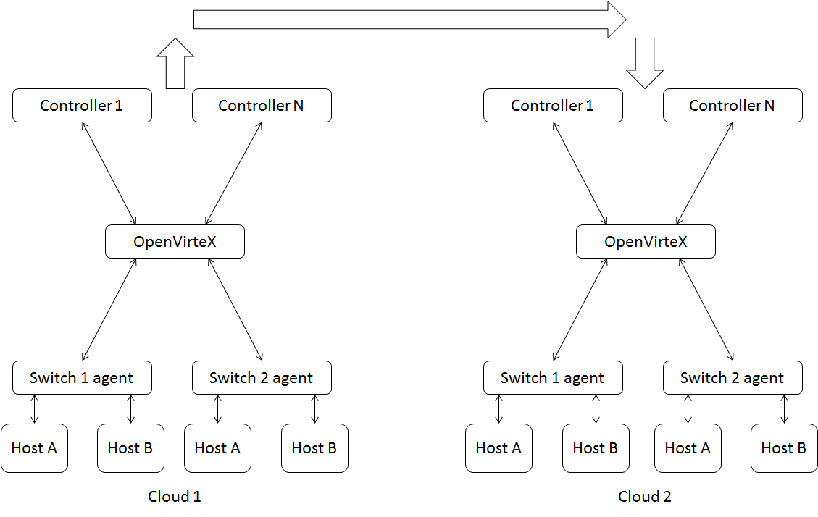

**Figure 1: High-Level Network Architecture**

Advantages of Mininet:

* We can create custom small to complex large scale topologies within few seconds. It uses Linux namespace for creation of virtual networks which is also used for Linux containers in application like Docker.
* We can run any application in Linux machine using that it work as application running from host.
* We can run Mininet on any Linux box or Amazon EC2 cloud.
* Mininet provide flexibility to customize packet forwarding using OpenFlow protocol.
* It is easy to understand and start writing Python scripts and experiment with the different topologies.

Limitations:

* Hosts or switches running on Mininet can’t go beyond resources shared by it. For example, on laptop we cannot create links with bandwidth 10 Gbps if it is not supported by physical system.
* Mininet can run on Linux host only. Thus, it can’t run applications that support only Windows or BSD OS.
* By default, Mininet remain isolated from LAN. Although, we can use NAT object --nat option to connect to Mininet network via LAN through NAT. Also, we can use real physical switch to connect Mininet interface.

When we start Mininet, it create instances of controller, switch and hosts by default. We need to mention provide number of host nodes with each switch and depth of the network to customize the topology.

**OpenFlow:** OpenFlow is open interface used to control forwarding tables of network devices (switches, routers, access points). It is standardized protocol for interacting with the forwarding behavior of switches from multiple vendors. This provides us a way to control the behavior of switches throughout our network dynamically and programmatically. OpenFlow is one of the key protocol in many SDN solutions.

How OpenFlow works:

In a classical router or switch, the fast packet forwarding (data path) and the high level routing decisions (control path) occur on the same device. An OpenFlow Switch separates these two functions. The data path portion still resides on the switch, while high-level routing decisions are moved to a separate controller, typically a standard server. The OpenFlow Switch and Controller communicate via the OpenFlow protocol, which defines messages, such as packet-received, send-packet-out, modify forwarding-table, and get-stats.

The data path of an OpenFlow Switch presents a clean flow table abstraction; each flow table entry contains a set of packet fields to match, and an action (such as send-out-port, modify-field, or drop).

When an OpenFlow Switch receives a packet it has never seen before, for which it has no matching flow entries, it sends this packet to the controller. The controller then makes a decision on how to handle this packet. It can drop the packet, or it can add a flow entry directing the switch on how to forward similar packets in the future. Flow table is controlled by a remote controller via secure channel.

**OpenVirteX (OVX):** OpenVirteX is a network virtualization platform which allows you to specify your own topology and addressing while retaining control of your virtual OpenFlow network. In essence, we are introducing the concept of programmable virtual networks. OVX sits in between the physical hardware and the virtual network controllers.

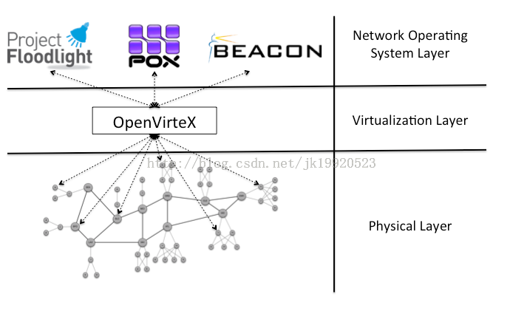

**Figure 3: High-Level view of a Virtual Network**

It allows you to:

* Create isolated virtual networks with a topology you specify,
* Use your own Network Operating System, Use the whole address space,
* Change your virtual network at runtime, and automatically recover from physical failures.

**SDN Controller:** An SDN Controller in a software-defined network (SDN) is the “brains” of the network. It is the strategic control point in the SDN network. We will be using OpenDaylight SDN controller in the project.

**OpenStack Neutron:** Neutron is part of OpenStack provide 'network as service' between interface devices managed by other OpenStack services (eg. Nova) it provides a way for organizations to relieve the stress on the network in cloud environment to make it easier to deliver Naas in the cloud. We will be using OpenStack neutron to connect our SDN network with the OpenStack cloud.

1. **Acceptance Criteria**

The minimum acceptance criterion shall be when we are able to send packets from Host A (connected to switch 1 or 2) located in cloud 1 to Host B (connected to switch 1 or 2) in cloud 2. Controller 1 and Controller N are in different networks.

Networks 1 and 2 shall be installed in separate VMs denoting they are part of different clouds under different administrative domains.

The stretch goals include:

* Solving Design challenges like isolating multiple traffic across different Administrative boundaries and bridging from cross pods to cross clouds.
* -Solving the administrative problem of mutual agreement (QoS, bandwidth) between multiple vendor
* Exploring Open stack neutron interface APIs for supporting OpenDaylight
* Integrating OpenDaylight and the current topology to OpenStack neutron

1. **Release Planning**

Detailed user stories and plans are on Trello board

<https://trello.com/b/n1veivu7/network-programmability-as-a-cloud-service>

* Release 1 (due by week 5):

User Story: Creating a network for a tenant (user).

-Creating topology using Mininet

-Using a single OpenDaylight (ODL) Controller to send packets across multiple open virtual Switches in Mininet using OpenFlow.

* Release 2 (due by Week 7):

User Story: Creating a private cloud for a single tenant (autonomous system 1).

-Introducing multiple networks in the current topology

-Connecting multiple networks using GRE tunnel

* Release 3 (due by Week 9):

User Story: Introducing OpenVirteX as an abstraction layer to support services across multiple switch (hardware) vendors and controllers for the tenant.

-Inserting OpenVirteX as a virtualization layer between controllers and Open Virtual Switches.

* Release 4 (due by week 11):

User Story: Introducing tenant 2 (autonomous system 2) and facilitating communication across clouds.

-Creating the same design as above using ONOS controller in a separate VM.

-Linking the two designs by connecting the two VMs (bridging from cross pods to cross clouds).

* Release 5 (due by week 13):

User story: Solving agreement problems in a multitenant environment like MOC.

-Solving Design challenge 1: Traffic isolation across multiple AS domains

-Solving Design challenge 2: Bandwidth, QoS agreement across multiple tenants in MOC environment.

**References:**

1. Networking in Massachusetts Open Cloud (MOC) - Cisco Presentation by Dr. Somaya Arianfar